Assessment Schedule – 2015
Physics: Demonstrate understanding of mechanics (91171)
NØ | N1 | N2 | A3 | A4 | M5 | M6 | E7 | E8
No relevant evidence. | Very little Achievement evidence. | Some evidence at Achievement level; partial explanations. | Most evidence at Achievement level. | Nearly all evidence at Achievement level. | Some evidence at Merit level with remainder at Achievement level. | Most evidence at Merit level with some evidence at achievement level. | Evidence provided for most tasks, but weak or incomplete at Excellence level. | Evidence provided for most tasks and is accurate and full at Excellence level.
No response; no relevant evidence. | 1a | 2a | 3a | 4a | 2m + 1a | 2m + 2a | 2m + 1e | 1e + 2m + 1a
Other combinations are also possible. However, for M5 or M6 at least one Merit question needs to be correct. For E7 or E8 at least one Excellence needs to be correct.

Q | Evidence | Achievement | Merit | Excellence
ONE  (a) | F_{g} pointing vertically down for C and G. Same size for both positions.  Horizontal arrow v_{H} of the same size for both positions, B and H.  Arrow v_{V} pointing vertically up at D and pointing vertically down at F, same length. | Two out of three correct. | All three correct including relative size of arrows.
(b) | V_{h} = 16 cos 42° = 11.89 m s^{–1} (=12 ms⁻¹)  V_{v} = 16 sin 42° = 10.71 m s^{–1} (= 11 ms⁻¹) | Both correct.
(c) | The vertical velocity of the ball is zero at the top, but the horizontal velocity will be  11.9 m s^{–1}. There are no horizontal forces. Gravity acts vertically down. | Vertical velocity is zero.  AND  Horizontal velocity is constant.  OR  One correct velocity with correct explanation. | Complete answer giving reasons why horizontal velocity is constant (no horizontal force) but vertical velocity decreases to zero (gravity).
(d) | Time taken to reach maximum height:  v_{f} = v_{i} + at  0 = 10.71 – 9.8t  t = 1.09 s  Total time = 2 × 1.09 = 2.18 s  Range = d = vt  d = 11.89 × 2.18  = 26 m | Correct time of 1.09 s | Correct total time or one error in calculation.  OR  Two correct steps. | Correct answer.

TWO  (a)(i) | Either conservation of momentum or Newton’s first, second or third law. (Cannot be conservation of energy.) | One correct law.
(ii) | Momentum is conserved.  5.0m = (65 + m)2.2  5.0m – 2.2m = 143  m = 51 kg | Recognition that momentum is conserved.  OR  Correct expression for p_{before} or p_{after}  OR states  Δp = 143 | Correct answer for mass.  AND  Correct assumption.
(iii) | Momentum was conserved in the absence of external force.  There is no friction with ice. Friction is an external force. | States that momentum is conserved in the absence of an external force.  OR  Recognition of the absence of external force since ice is frictionless. | Reasons out that friction is an external force and this is zero due to the presence of ice, in order for momentum to be conserved.
(b) | Janet must bend her knees while jumping to the ground. Bending her knees increases her stopping time so the force decreases. This is because the change in momentum remains the same.  Δp = FΔt  Accept correct argument in terms of F = ma. | Janet needs to bend her knees. | Janet needs to bend her knees.  AND  Recognition that this increases stopping time, thus reducing the force. | Complete answer including Δp is the same regardless of whether the knees are bent or not.
(c) | Her momentum is not conserved. This is because gravity acts as an external force. | Correct answer with reason.

THREE  (a) | 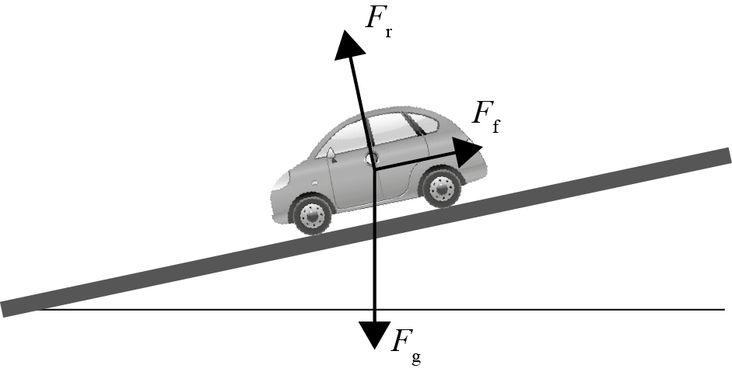 | All three arrows correct F_{g}, F_{f}, F_{r} and labelled (with directions not perfect).  OR  Two forces perfectly correct – ignoring ‘extras’. | Arrows drawn such that there is a 90° angle between F_{r} and F_{f}, and F_{g} is vertically down and no extra forces.
(b) | 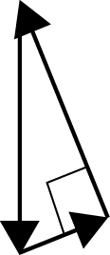  Forces are balanced/in equilibrium. So, the component of gravity down the slope = friction force, and the component of gravity into the slope = reaction force. | Forces are balanced.  (NB do not accept ‘equal’.) | Complete answer.  Accept labelled closed vector triangle with force directions approx. correct as the reason why forces are balanced.
(c) | F_{g} =1500 × 9.8 =14700 N  Component of gravity acting into the ground = 14 700 cos12° = 14378 N  This is equal to reaction force.  Component of gravity acting down the slope = 14 700 sin12° = 3056 N  Hence friction force acting up the slope = 3056 N.  Since car is stationary, component of F_{g} into the slope = F_{r}.  And component of F_{g} down the slope = F_{f} up the slope. | Recognition of the components of gravity acting into the slope = F_{r}.  OR  Component of F_{g} into the slope = Friction force up the slope.  OR calculates F_{g} correctly. | One mistake.  E.g. both F_{f} and F_{r} calculated correctly, but no statement of which is which. | All correct.
(d) | 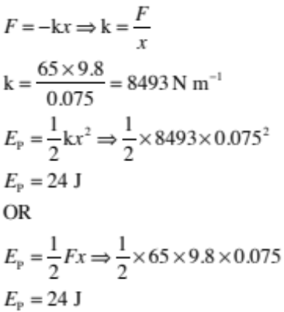 | Correct value of k.  OR  One error in calculation.  (Allow © for k value.) | Correct answer.

FOUR  (a) | Even though the ball is travelling at constant speed, it is changing its direction of motion continuously. A change in either speed or direction is acceleration, hence the ball in circular motion is accelerating. | Correct answer.
(b) | 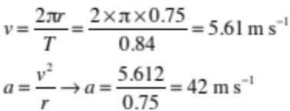 | Correct answer for velocity.  OR a calculated correctly with ©. | Correct answer.
(c) | The tension in the cord provides centripetal force, which is the unbalanced force (causing acceleration). | Tension provides the centripetal force. | Recognition that tension is the unbalanced force (that causes acceleration).
(d) | Taking B as pivot (or moments about B),  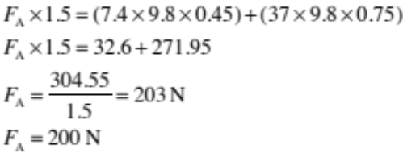 | Correct substitution for one direction of torque about specified end.  AND correct torques. | One mistake.  E.g. final answer for F_{B} (232 N) instead of F_{A} | All correct.

Cut Scores
Not Achieved | Achievement | Achievement with Merit | Achievement with Excellence
0 – 7 | 8 – 16 | 17 – 24 | 25 – 32

